Create Method Security Level

- Create Configuration in the security
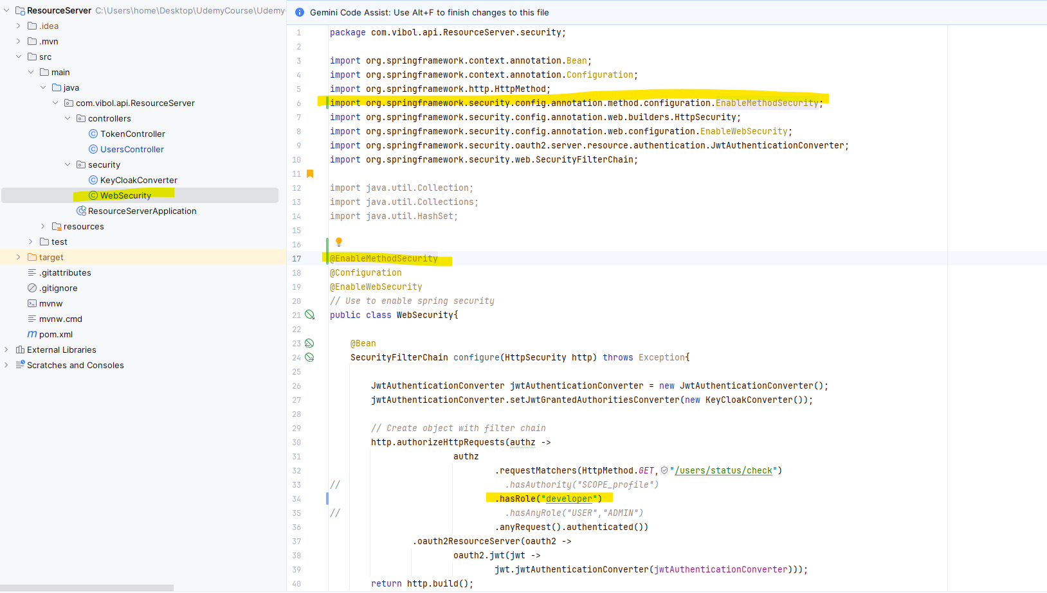

- Crate the controller that we need to put the security

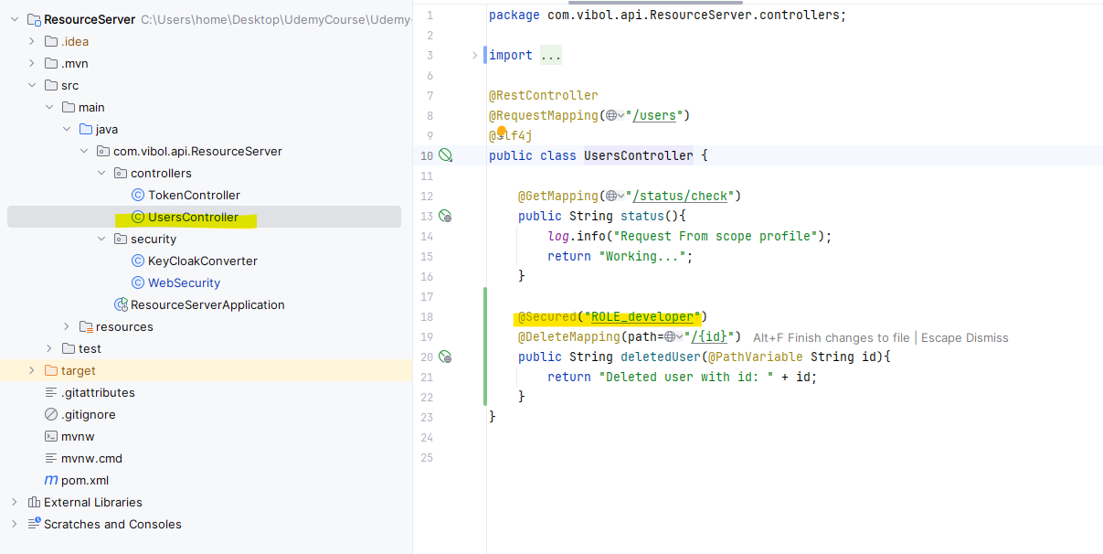

Testing with Postman

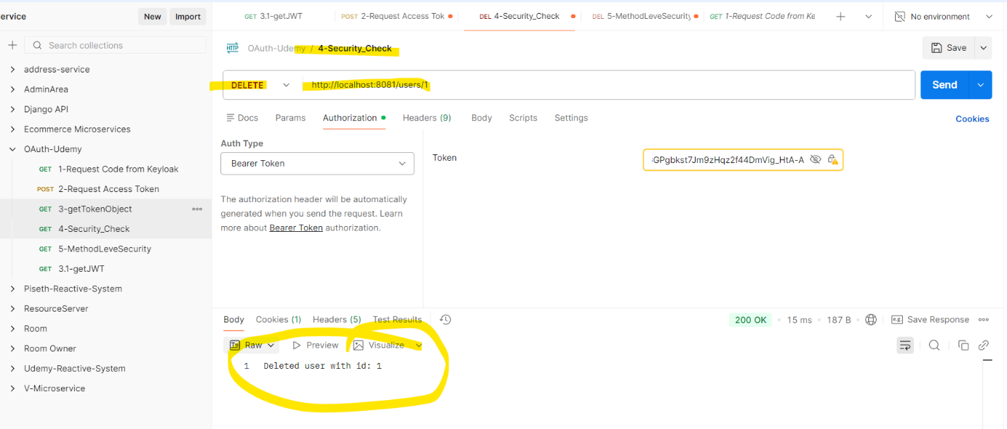

If we change the “ .hasRole("developer") “ ទៅ Role_user វិញវាមិនអាចចូលបានទេ

